ID: Embodied Interactions

**Initial Research**

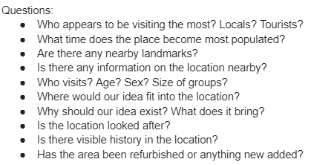From the offset my group and I had decided on Clifton Suspension Bridge, especially after our visit there. However, the visit came with a lot of enlightenment on various factors as well as reflection on our original angle. Initially, we wanted to create an interaction that was based on the suicide history of the bridge, however once we talked to the on-site manager of the Visitor Centre, it became very apparent we would not be able to access data, nor were the guides keen on the idea. As a result of this, we looked into other factors of the bridge which were discovered through the use of our research questions before investigating the area onsite as shown in Figure 1.

Figure - Questions for Investigating Area

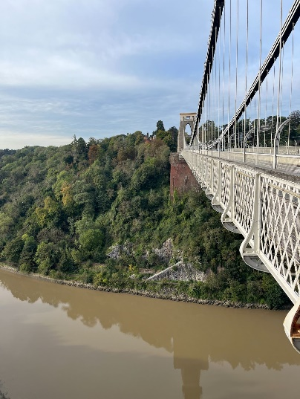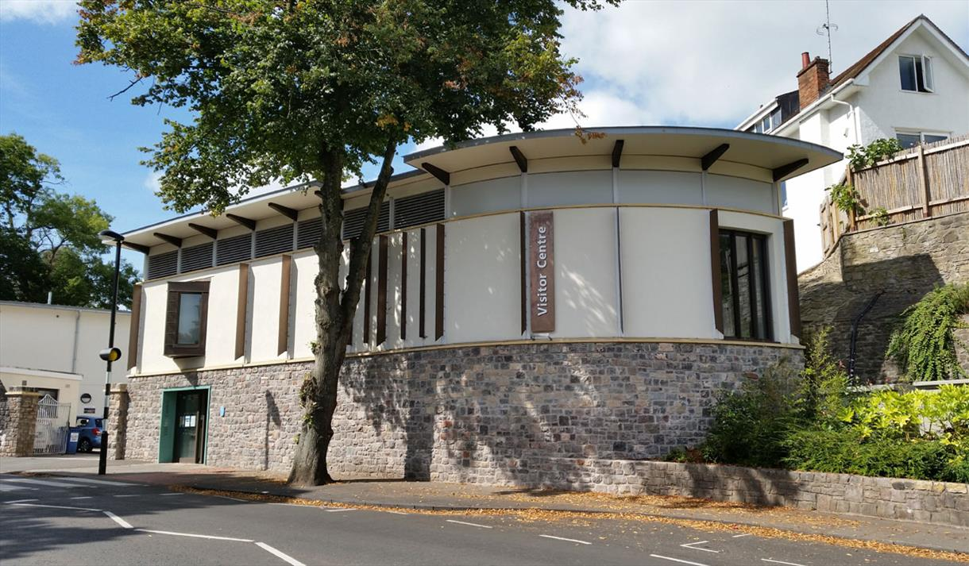During this process we noticed the Visitor Centre is heavily overlooked with little to no traction, this was including us. With this in mind, we focused our attention away from the bridge and more on the Visitor Centre and how a suitable interaction could possibly increase visitors.

Figure - Clifton Suspension Bridge & Visitor Centre

The questions in Figure 1 aided us in discovering the real problems in the area, “it is all too easy to see only the surface problems and never dig deeper to address the real issues”.[1] Therefore, we were very thorough in conducting our investigations.

**Design Brief**

After observing the area, we noticed two important factors:

1. There were a lot of school trips into the area or pedestrians with kids.
2. The bridge/visitor centre was missing a source of entertainment.

Following the Double-Diamond Model of Design, as covered by Norman, 2013 we “converged upon a single problem statement”.[2]

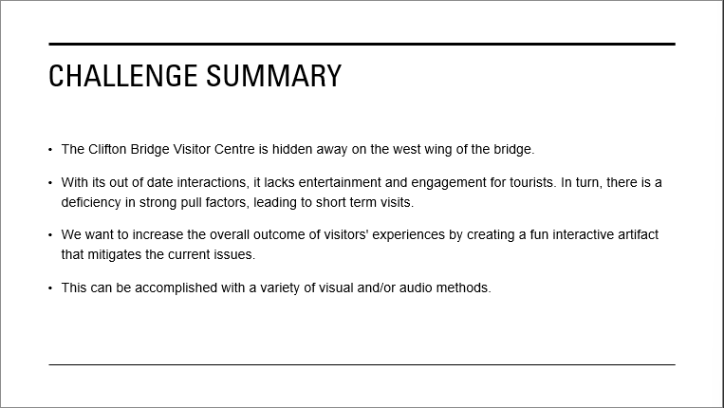

Figure - Design Brief Challenge Summary

As Don Norman states, “never start by trying to solve the problem given… start by trying to understand what the real issues are”[3].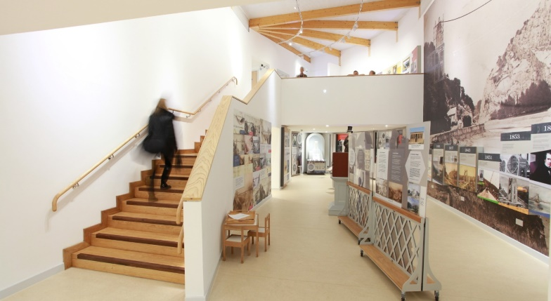 In consideration of this, we engaged in talks with the onsite manager of the centre and were informed that the place was an educational facility but there was indeed room for entertainment in the centre. The centre has two floors with a few interactions.

The first floor has an interaction where you stand a scale, and it measures the bridges capacity of how many of the participant it can hold. As well as an architectural interaction that plays sounds when buttons are clicked.

Figure - Clifton Suspension Bridge Visitor Centre Interior

The second floor has a playroom for kids where they can construct bridges with blocks.

While interactions exist in the visitor centre they are not of great interest and lack a strong pull factor. Therefore, our design brief shaped into creating a design that would have people coming back to show others and engage with, specifically of a young demographic.

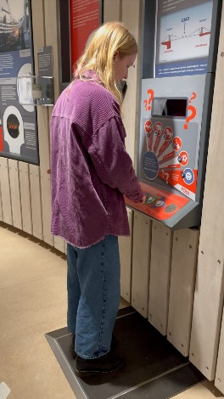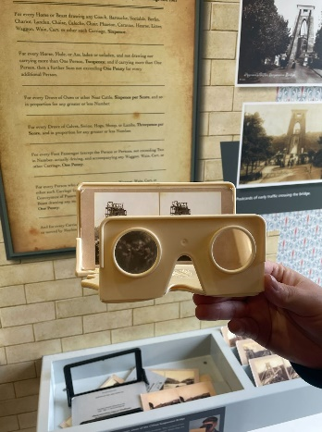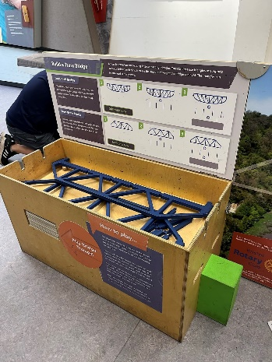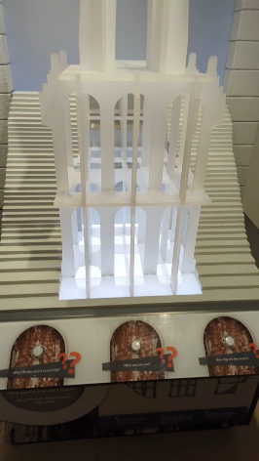**Design Research**

Figure - ­Interactions within Visitor Centre

Before developing an initial interaction, I conducted research into existing interactive designs. The goal was to help ideate possible design solutions for the Visitor Centre, this included research into sound design, motion detection as well as inherently interesting designs founded in the real world. “Interactive systems, physically embedded within real spaces, offer opportunities for interacting with tangible devices”[4] and so “meaning is created in the interaction”.[5]

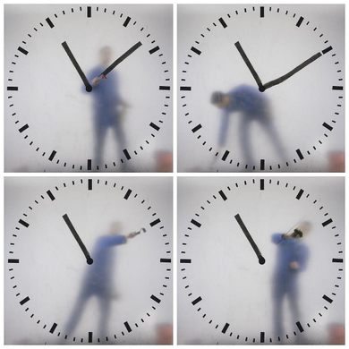One of the first interactions was “Colston’s Last Journey… an interactive audio project. A sea of interactive audio is layered over the centre of Bristol/UK”.[6] This was an eye-opening piece and allowed me to explore, “sensory richness and action potential of physical objects”.[7] Due to this interaction, it enabled me to construct the idea of possible noises within the bridge, perhaps as construction was going on. However, as mentioned earlier, this idea has already been established on the site leading to me to discontinue the idea.

Figure - Clock Screen in Schiphol Airport, Netherlands

Another inspiration was the clock interface in Schiphol Airport. This interesting and unique design showed that there was no limit to how outlandish a design idea could be, as long as it was accessible and provided a user with clear feedback and purpose. This was due to the design “building upon users’ experience of interacting with the real world lowering the threshold for activity”.[8]

Finally, there was research into motion detection, due to “increasingly being used in the design of interactives spaces, computer-mediated environments, and virtual user experiences”[9], our target audience of teens should potentially find such interaction second nature and understand the goal at a quick glance, alleviating the “access bottleneck”.[10] Additionally, motion sensors can “allow human and interface” to display “*coordinated effort* towards achieving a common goal”[11], in the case of my interaction, the common goal would be for the user to inform and educate the interface with movement and in return the interface will educate the user on the bridge while ensuring “the experience of use is positive and enjoyable”.[12]

**Early Design**

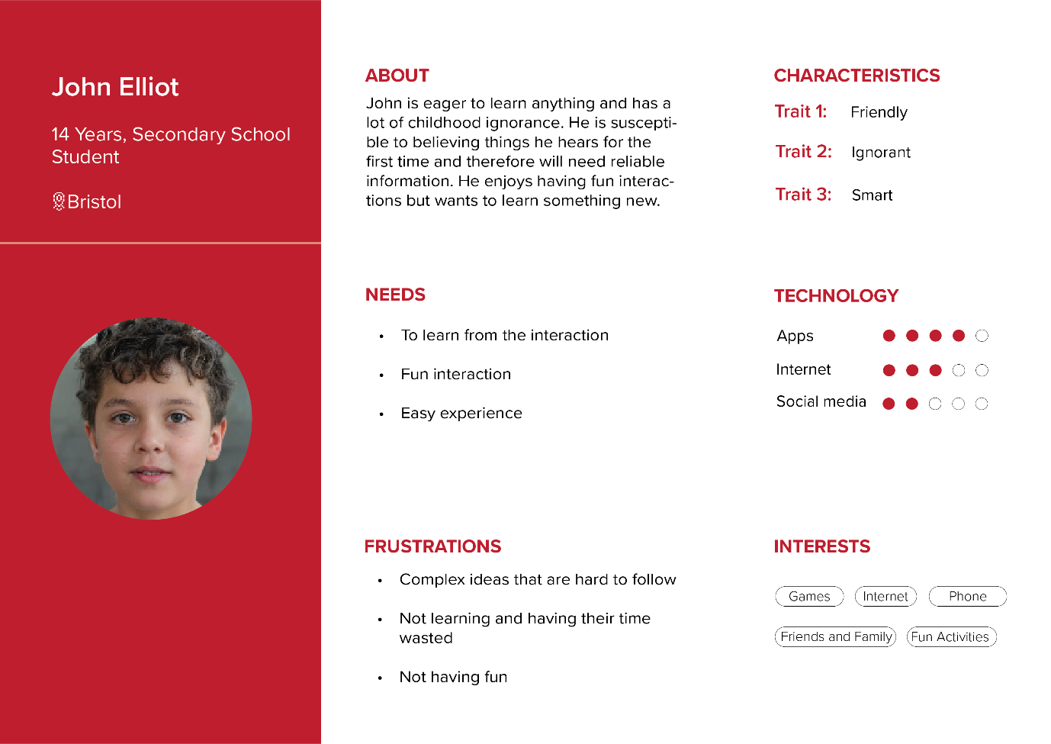After completing my research as well as configuring the design brief, I proceeded to create two user personas - one for a student and another for a teacher. It was key that I created one for both demographics as this will be the main focus of my interactions and I want the design to be inclusive and accessible to all.

Figure - Student User Persona

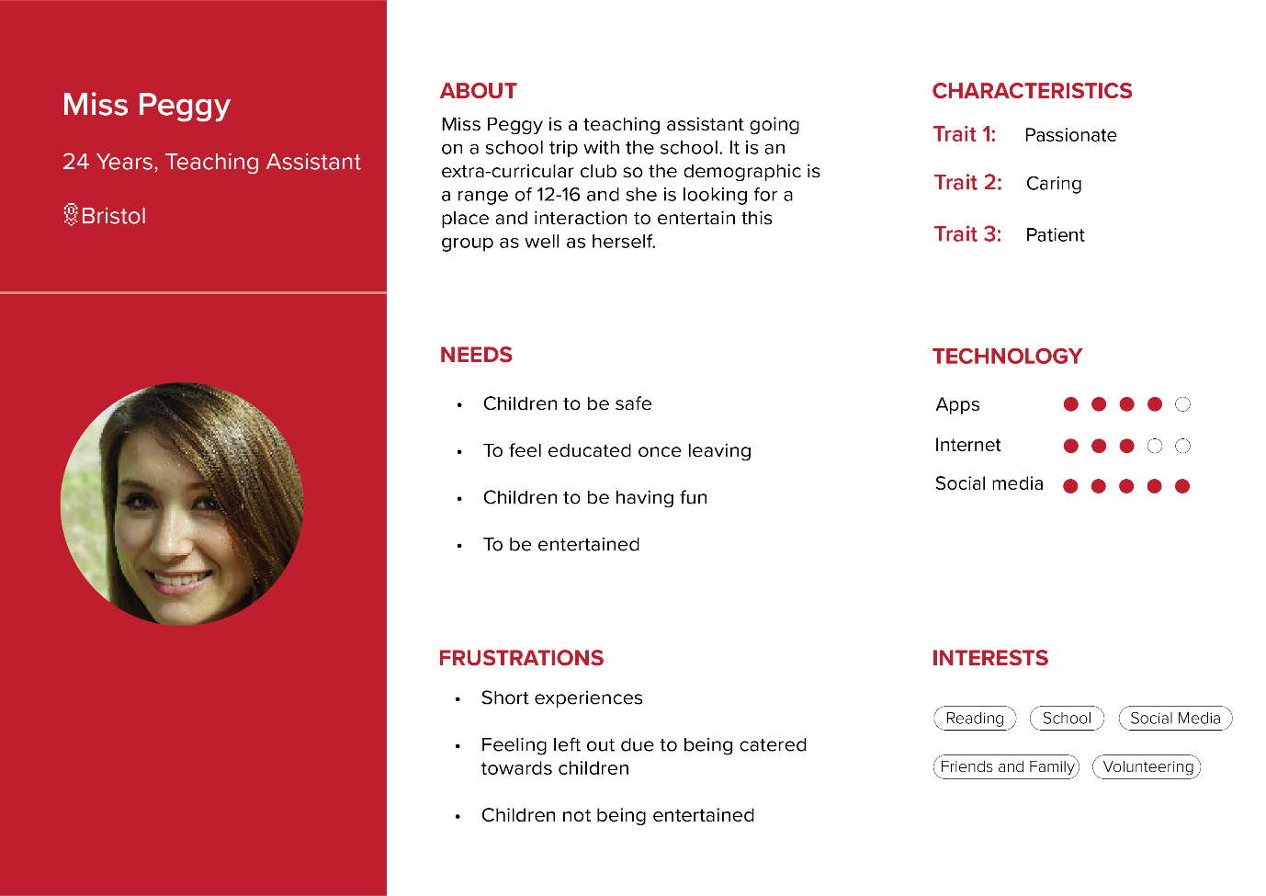

Figure - Teacher User Persona

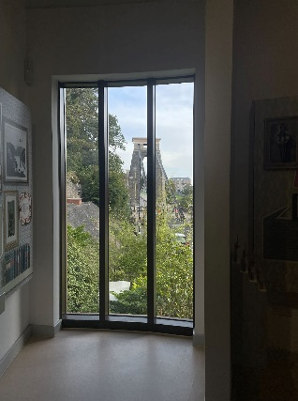Early design for my idea started as a tournament bracket for participants in the initial bridge design, this is so users can decide upon their own winner before seeing how their design choice compares towards the official bridge. The ideal position of placing this interaction will be within a clear view of the bridge, this means it will be placed on the second floor of the Visitor Centre as seen in figure 9.

Figure 9 - Clifton Suspension Bridge Visitor Centre Upstairs Window

For my interaction to work it required having a screen, this is because the initial idea was to have the users touch the screen to make their selection of what design was better in the tournament round. This is a showcase of “Human-Computer Integration (HCI)… with the key property that computers become closely integrated with the user”. However, due to wanting to increase interest and make the interaction appeal to my target audience, I decided upon on using motion sensor for entertainment purposes. This replaces the “HCI” and instead replaces it with “fusion… we define *fusion* as an integration in which devices extend the experienced human body or in which the human body extends devices… fused systems do not require explicit input from humans, but simply act as extensions of human bodies”.[13]

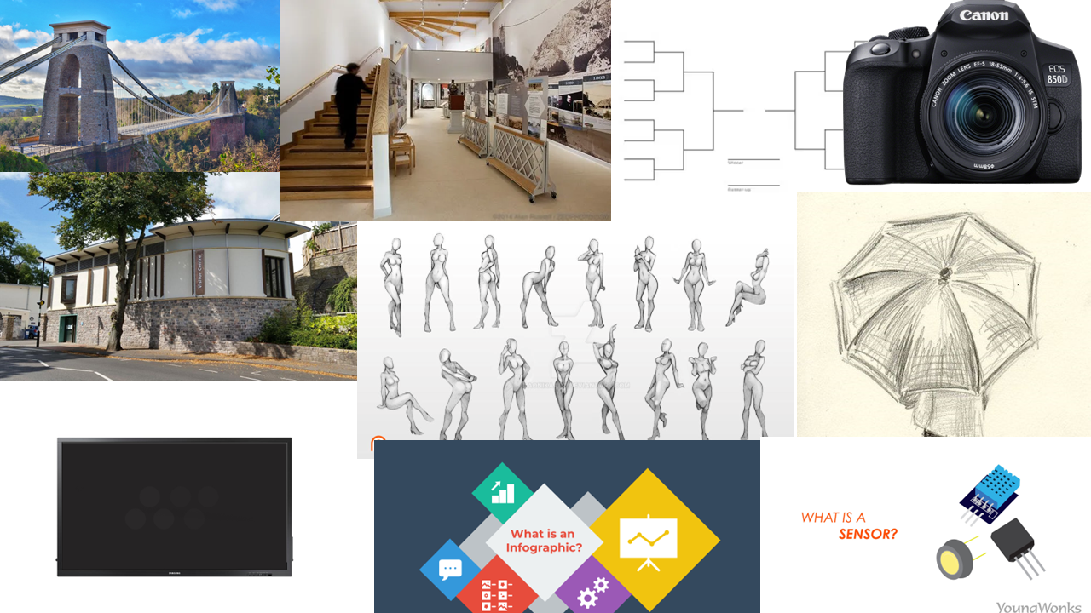

Figure 10 - Mood board

As seen in Figure 10, the ideation process for my design was to be informative and entertaining as pertaining to the design brief. With my initial design concept having been thought of I created a flow chart to demonstrate how the interaction would take place as well as a description of each stage.

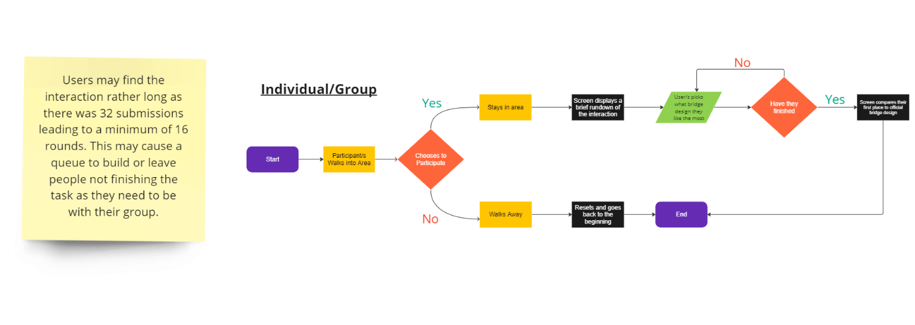

Figure 11 - Flow Chart of Interaction

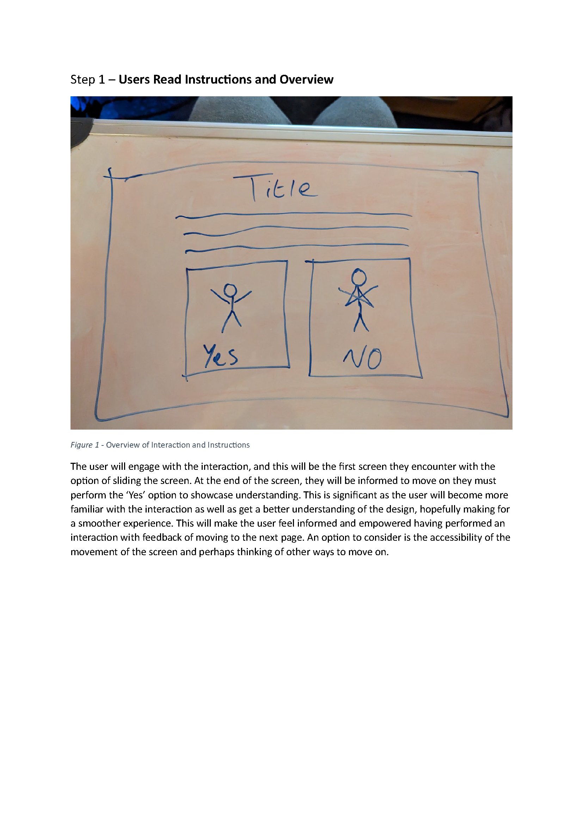

Figure 12 - Showcasing Step 1 - "Users Read Instructions and Overview"

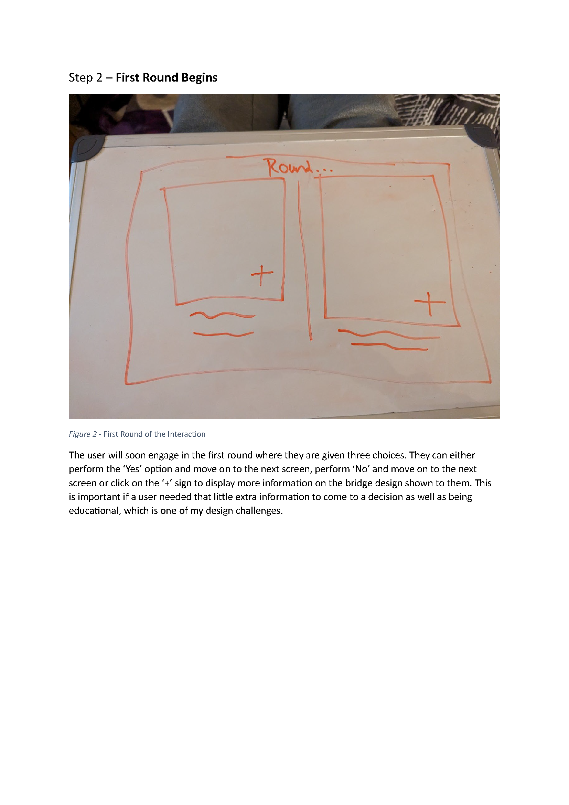

Figure 13 – Showcasing Step 2 – “First Round Begins”

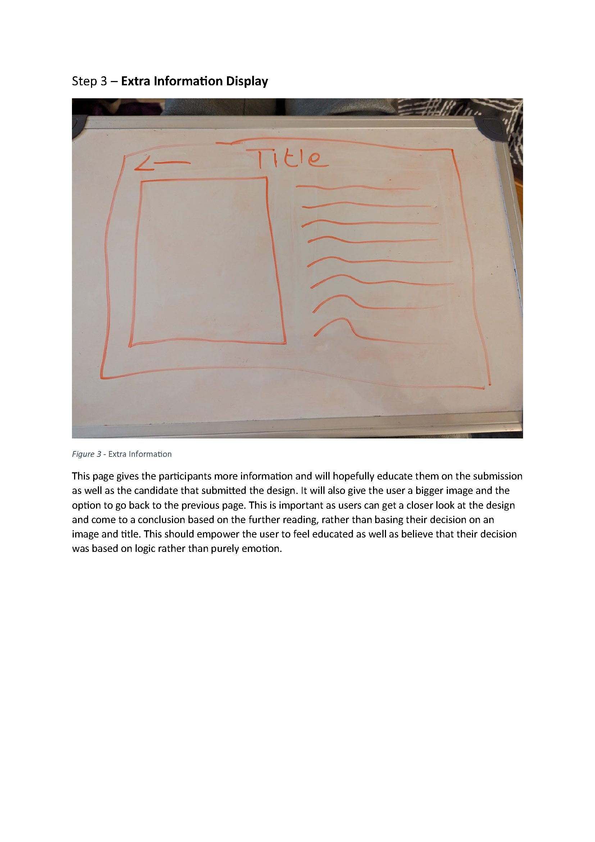

Figure 14 - Showcasing Step 3 – “Extra Information Display”

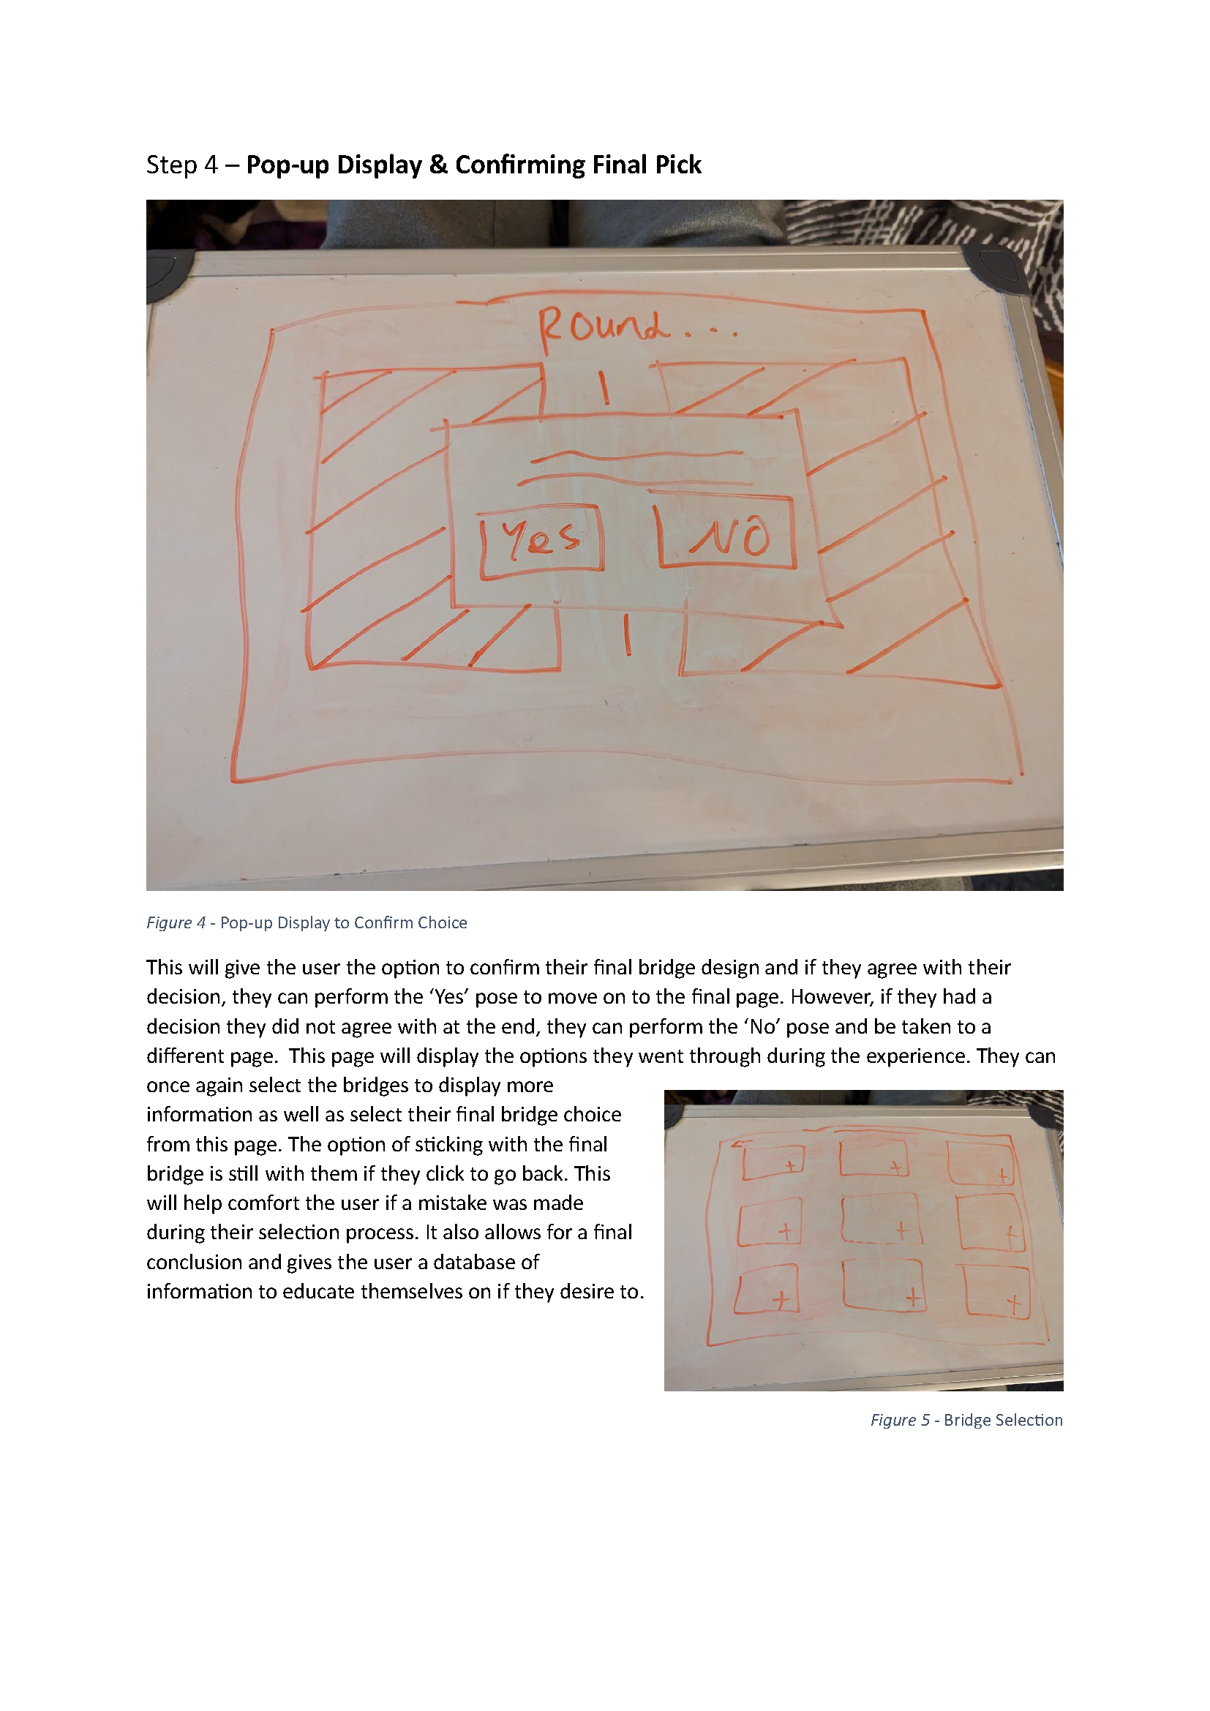

Figure 15 - Showcasing Step 4 - "Pop-up Display & Confirming Final Pick"

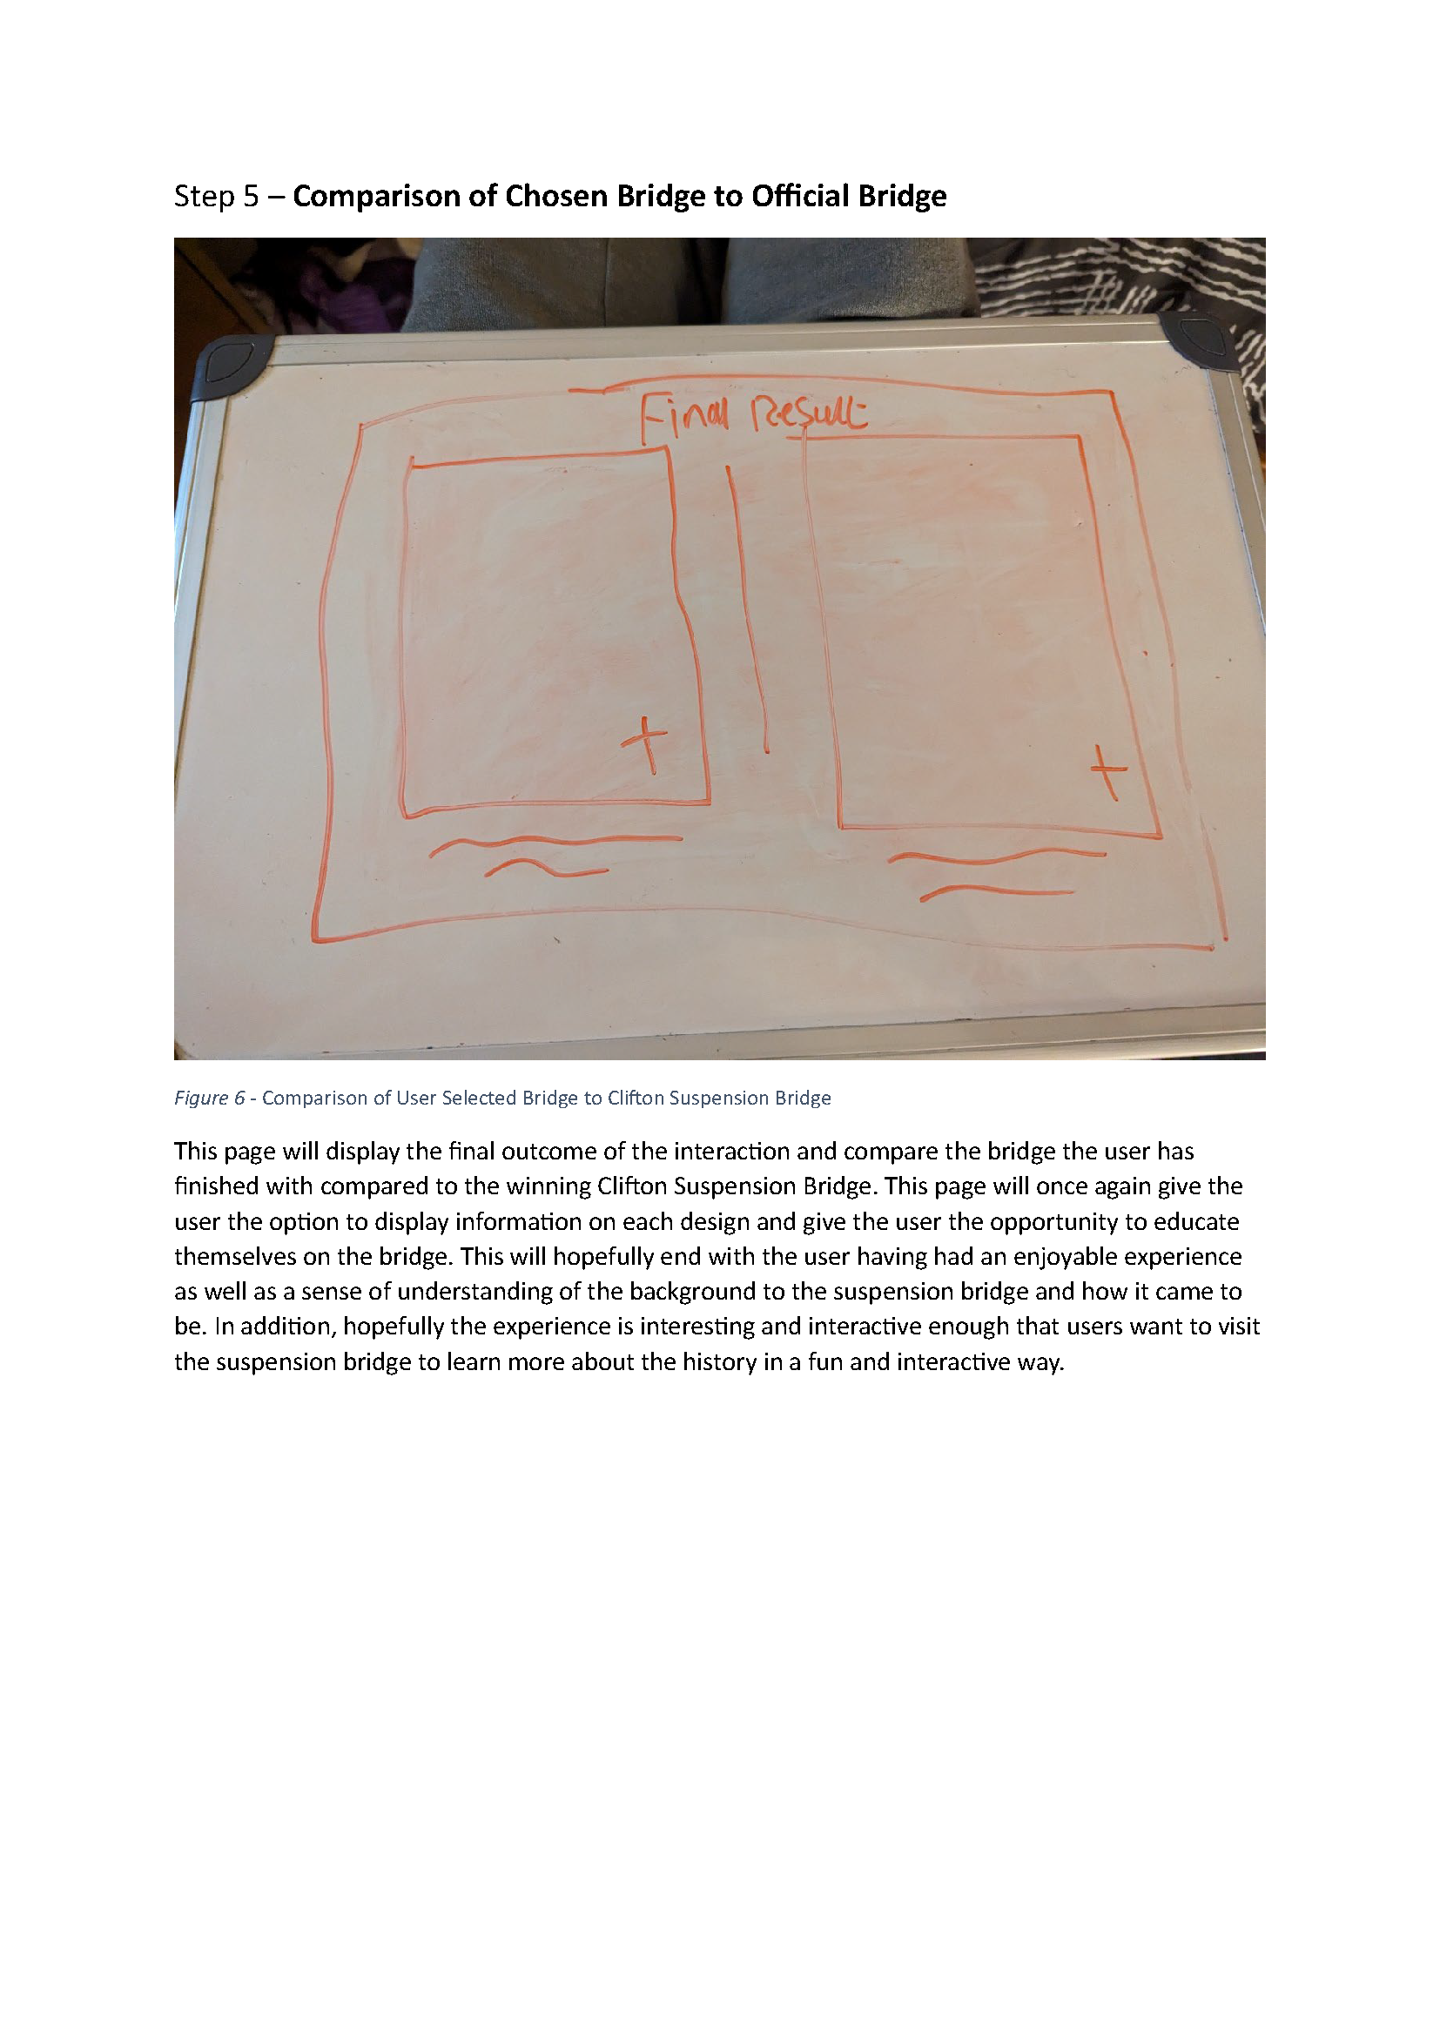

Figure 16 - Showcasing Step 5 - "Comparison of Chosen Bridge to Official Bridge"

Following the creation of my descriptive flow I compiled all the steps into a story board which accurately showcases how the interaction will respond in command to a user’s input. This was the final step for my ideation before moving towards creating a prototype.

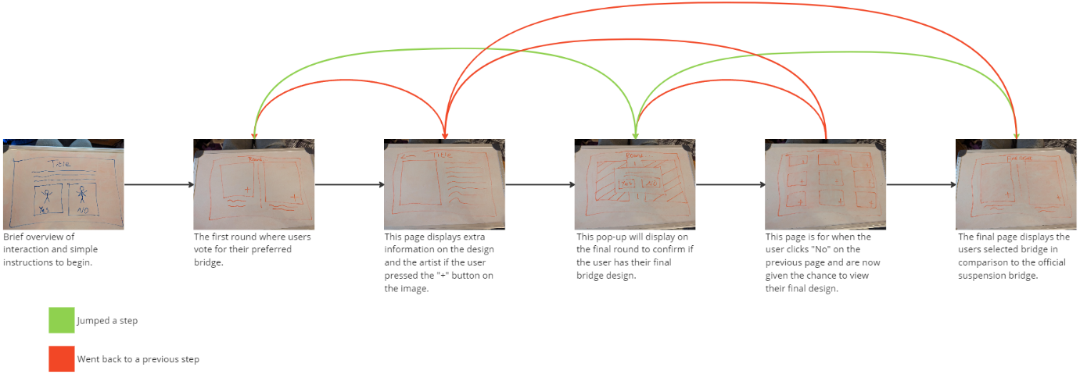

Figure 17 - Story Board for Interaction

**Final Design Solution & Prototype**

To portray my [prototype](https://youtu.be/WvPmam5z2W0), I created a video in Adobe After Effects which utilised a green screen and actors. I used this method to make a realistic demonstration of what the final interaction will be close to looking to.

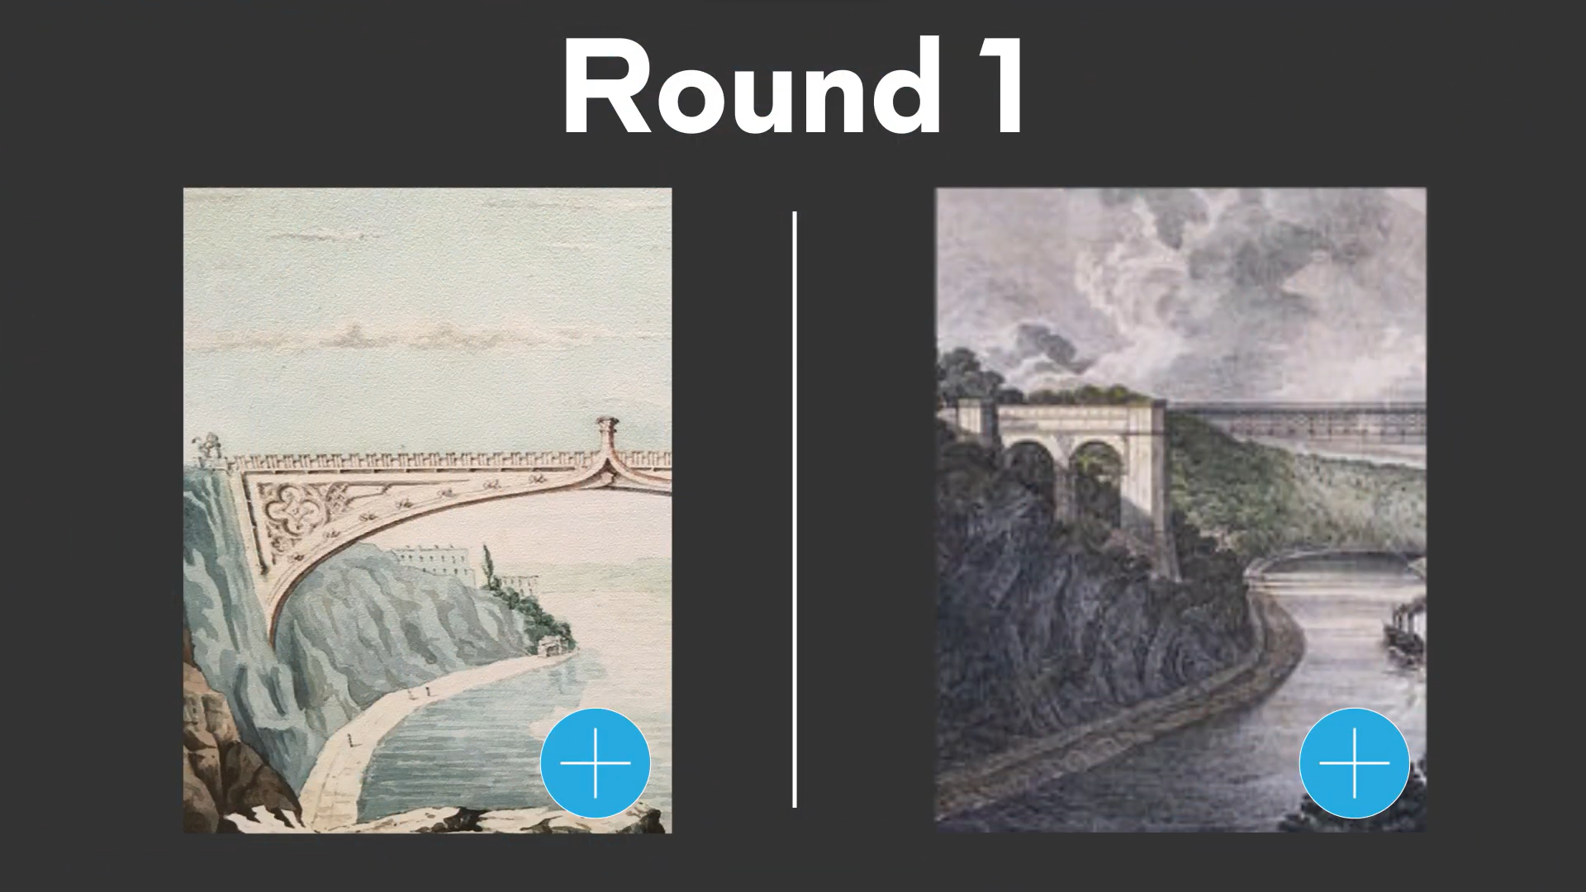

Figure 18 - Prototype Video

Figure 18 displays a basic layout of my [prototype video](https://youtu.be/1s3KQZPbQ7E) and close to what a screen will look like, this is based on Figure 13. The demonstration is short, showcasing two rounds and all the possible pages and interactions possible for my design.

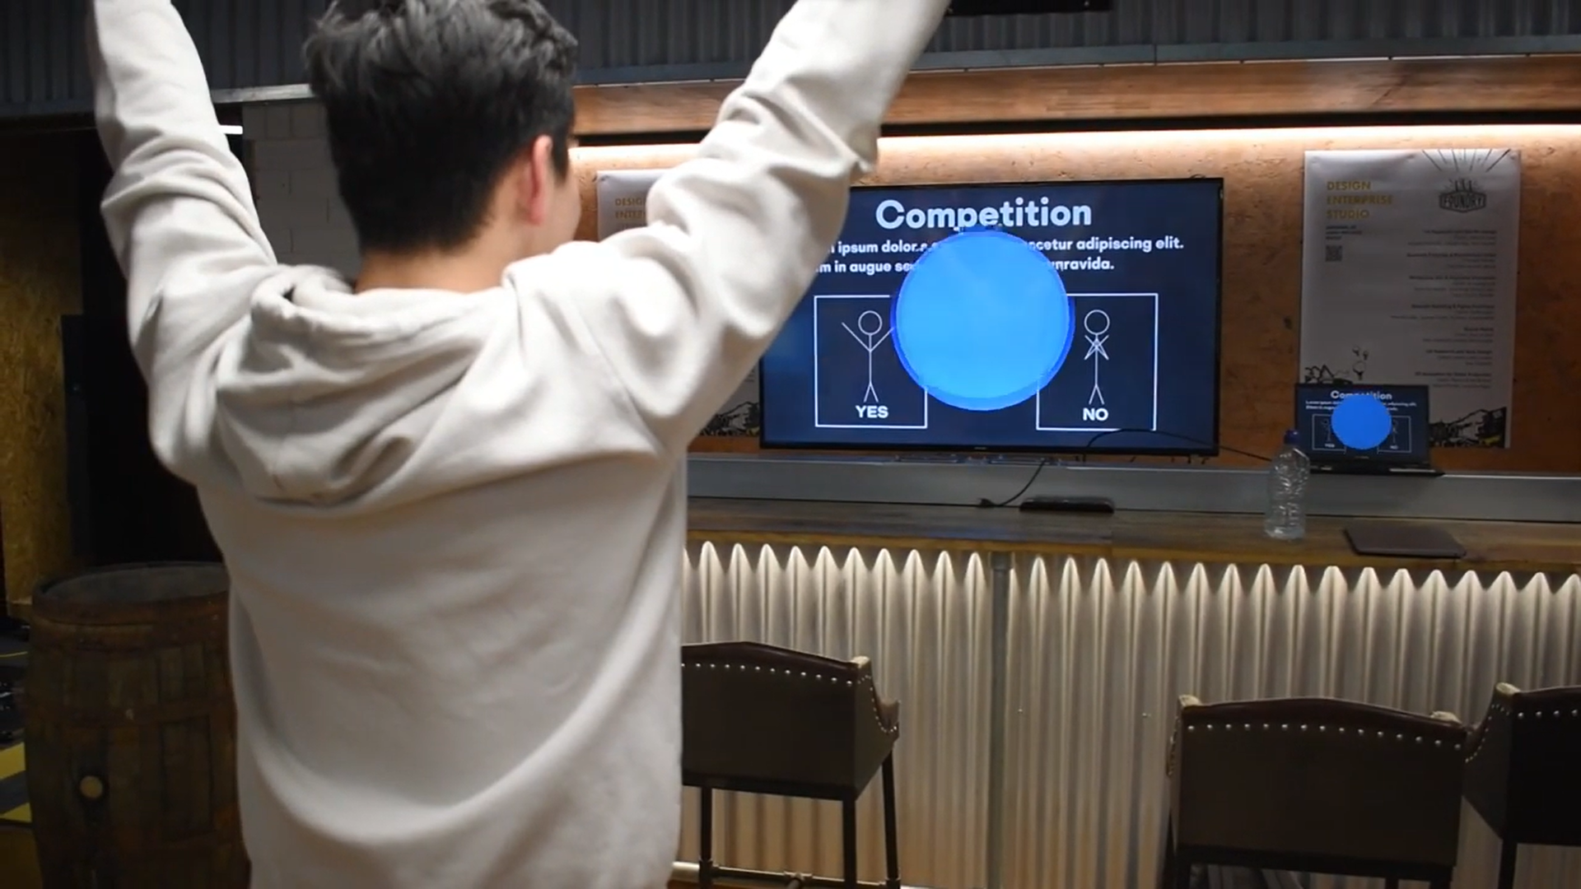

Figure 19 - Demonstration Video

Figure 19 displays a performance of the interaction and showcases one of the possible three states a user may be in. This current stance is a “Yes” stance to showcase they understood the instructions on the screen, this portion of the video is based on Figure 12.

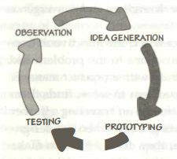During production of the prototype as well as recording a demonstration I “observed”[14] a few issues that should be addressed for the final production, the main problem was the lack of accessibility with the interaction. “Accessibility is making user interfaces perceivable, operable, and understandable for people with a wide range of abilities”.[15]

Figure 20 - The Iterative Cycle of Human Centred Design

The design heavily caters towards people who are mobile and has little regard for individuals who may not be able to perform the corresponding actions. As my target audience is youthful and the purpose is supposed to be entertaining, it is essential that I provide every individual with a chance of having fun. Therefore, it is imperative I add other possible interactions, this could be in the form of sound/speech, touching the screen or including other poses that do not involve arm movement but perhaps head movement instead.

Additionally, I want my design to be educational for my demographic, however the primary method of this is through visual information. As a result, I need to add an audio option to the interaction so who may have visual impairment can also gain from the experience equally. However, the interaction is primarily visual and relies heavily on users being able to see the screen to choose the image they desire to win. Therefore, a user who has a visual impairment will need some assistance with the interaction, this will mean I will need my motion sensor to be able to detect more than one user and still function correctly. To accomplish this, I will need the sensor to assign roles to participants such as who has the dominate position, so decisions are not interrupted outside of their choice. “Accessibility also makes products more usable in a wide range of situations – circumstances, environments, and conditions”. [16]

Furthermore, the interaction is currently very bare and repetitive, to truly make this a source of entertainment, I will need to add a few more possible interactions or methods throughout the interaction to retain the participants attention.

**Conclusion**

Overall, the design is effective in creating an educational interaction which will inform users of the bridge and its history, adding as a new interactive piece for the Visitor Centre. However, as the Centre already has a section for the judging and subsequent bridge ideas, the design needs to possibly add another feature or make the form of education more entertaining to have a long-term purpose of staying within the Centre.

As previously stated, the design has a few accessibility issues which will need to be considered before the final product, however the interaction fulfils its job of being an entertaining and educational interaction for the target audience.

The next step for the interaction would be to increase the entertainment factor, resulting in more visitors to the Centre. This can be accomplished with new features to the design as well as making the design more accessible for a variety of audiences. One such audience would be young adults, similar to *Miss Peggy* from Figure 8. Additionally, the design could benefit from more feedback to the user, so they may feel a sense of accomplishment after performing an action.

**References**

Atlas Obscura (2018) *Schiphol Clock.* Available from: <https://www.atlasobscura.com/places/schiphol-clock> [Accessed 07 December 2023].

Ciolfi, L. (2004) Situating 'Place' in Interaction Design: Enhancing the User Experience in Interactive Environments. PhD, University of Limerick. [Accessed 30 November 2023].

Colstons Last Journey (2023) *Colstons Last Journey.* Available from: <https://www.uwe.ac.uk/study/study-support/study-skills/referencing/uwe-bristol-harvard#webpages> [Accessed 07 December 2023].

Djajadiningrat, T., Overbeeke, K. and Wensveen, S. (2002) But how, Donald, tell us how? Proc. of DIS'02 [online]. pp. 285-291. [Accessed 30 November 2023].

Escamilla, A. Melenchón, J. Monzo, C. and Morán, J, A. (2012) Interaction designers’ perceptions of using motion-based full body features. *International Journal of Human Computer Studies* [online]. Volume 155. [Accessed 07 December 2023].

Great West Way (2023) *Clifton Suspension Bridge Visitor Centre.* Available from: <https://www.greatwestway.co.uk/see-and-do/clifton-suspension-bridge-visitor-centre-bristol-p1389081> [Accessed 07 December 2023].

Henry, S, L. (2007) *Just Ask: Integrating Accessibility Throughout Design* [online]. Second Edition. Lulu.com. [Accessed 15 December 2023].

Hornecker, E. Buur, J. (2006) Getting a Grip on Tangible Interaction: A Framework on Physical Space and Social Interaction. *CHI 2006 Proceedings* • *Designing for Tangible Interactions* [online]. [Accessed 30 November 2023].

Mueller, F, et al. (2020) *Next Steps in Human-Computer Integration* [online]. Honolulu: ACM. [Accessed 09 October 2023].

Norman, D (2013) *The* *Design of Everyday Things* [online] Cambridge: MIT Press. [Accessed 15 December 2023].

Rydon (2023) *Clifton Suspension Bridge Visitor Centre.* Available from: <https://www.rydon.co.uk/clifton-suspension-bridge-visitor-centre> [Accessed 07 December 2023].

Stanton, D. et al. (2001) Classroom Collaboration in the Design of Tangible Interfaces for Storytelling. Proc. of CHI'01 [online]. pp. 482-489. [Accessed 30 November 2023].

**Bibliography**

Brunel 200 *The Clifton Suspension Bridge.* Available from: <http://www.brunel200.com/suspension_bridge.htm> [Accessed 30 November 2023].

Ciolfi, L. (2004) *Situating 'Place' in Interaction Design: Enhancing the User Experience in Interactive Environments*. PhD, University of Limerick. [Accessed 30 November 2023].

Clifton Suspension Bridge Trust (2023) *Visitor Centre*. Available from: <https://cliftonbridge.org.uk/visit-explore/visitor-centre/> [Accessed 16 October 2023].

Djajadiningrat, T., Overbeeke, K. and Wensveen, S. (2002) But how, Donald, tell us how? *Proc. of DIS'02* [online]. pp. 285-291. [Accessed 30 November 2023].

Hornecker, E. Buur, J. (2006) Getting a Grip on Tangible Interaction: A Framework on Physical Space and Social Interaction. *CHI 2006 Proceedings* • *Designing for Tangible Interactions* [online]. [Accessed 30 November 2023].

Stanton, D. et al. (2001) Classroom Collaboration in the Design of Tangible Interfaces for Storytelling. *Proc. of CHI'01* [online]. pp. 482-489. [Accessed 30 November 2023].

Visit Bristol (2023) Clifton Suspension Bridge. Available from: <https://visitbristol.co.uk/things-to-do/clifton-suspension-bridge-p24661> [Accessed 16 October 2023].

Wikipedia (2023) *Clifton Suspension Bridge*. Available from: <https://en.wikipedia.org/wiki/Clifton_Suspension_Bridge> [Accessed 16 October 2023].

1. Norman, D (2013) The Design of Everyday Things. pp.218
2. Norman, D (2013) The Design of Everyday Things. pp.220
3. Norman, D (2013) The Design of Everyday Things. pp.218
4. Djajadiningrat, T., Overbeeke, K. and Wensveen, S. (2002) But how, Donald, tell us how? pp. 285-291
5. Ciolfi, L. (2004) Situating 'Place' in Interaction Design: Enhancing the User Experience in Interactive Environments.
6. Colstons Last Journey (2023)
7. Ciolfi, L. (2004) Situating 'Place' in Interaction Design: Enhancing the User Experience in Interactive Environments.
8. Hornecker, E. Buur, J. (2006) Getting a Grip on Tangible Interaction: A Framework on Physical Space and Social Interaction
9. Escamilla, A. Melenchón, J. Monzo, C. and Morán, J, A. (2012) Interaction designers’ perceptions of using motion-based full body features.
10. Stanton, D. et al. (2001) Classroom Collaboration in the Design of Tangible Interfaces for Storytelling.
11. Mueller, F, et al. (2020) Next Steps in Human-Computer Integration
12. Norman, D (2013) The Design of Everyday Things. pp.219
13. Mueller, F, et al. (2020) Next Steps in Human-Computer Integration
14. Norman, D (2013) The Design of Everyday Things. pp.222
15. Henry, S, L. (2007) *Just Ask: Integrating Accessibility Throughout Design. pp. 2*
16. Henry, S, L. (2007) *Just Ask: Integrating Accessibility Throughout Design. pp. 2*